Photonic Integrated Circuits
Emner:
1. Light-matter interaction
2. Bandgap to waveguides
3. On-chip light sources
4. Miniaturization and scalability
5. Material platforms
6. Semiconductor growth and visible photonics
8A. Recombination processes
- Bølgenummer som vektor, direkte eller bølgenummers forskudt rekombination,
eller rekombination vha. Momentum. Fangne tilstande grundet forskellighed i materialers krystalgitre ( 550pm er ikke 560pm ).
- $ψ\left(r\right)=u\left(r\right)e^{ik·r}$ er potentialet
krævet for en elektron til at undslippe
sin nuværende position.
- $r$ er en vektor vektor vi bruger til at
beskrive propagering.
- $u\left(r\right)$ beskriver krystalstrukturens
periode for propagering i r.
- $k$ er vores bølgevektor, men
beskrives ikke helt så simpelt
som for 1 dimensionel
propagering
$\left|\vec{k}\right|=\frac{2π}{λ}$
$∠k=angle of propagation$
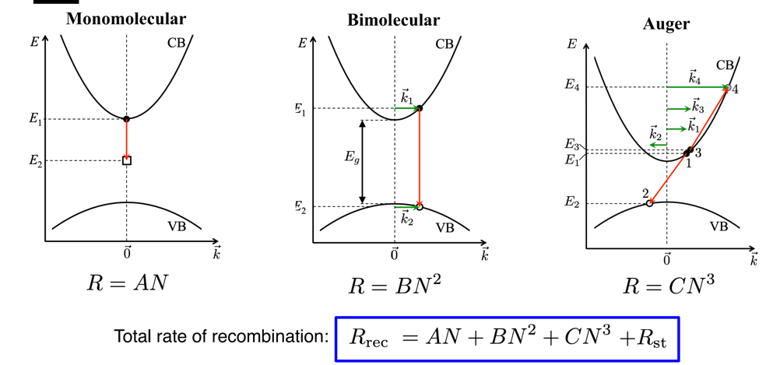

8B. Laser performance
9. Dynamics
10. Amplification and multiplexing
11. Semiconductor optical amplifiers
12. Phase modulation

Opgaver

Photons

What is a photon?
A package of wavelengths in the visible light spectra.

What is the energy of a photon with a wavelength of 1550 nm? Is it possible to amplify the energy of photons?
$E=h·f$
$v=λ·f$
$E=h·\frac{v}{λ}$
$Definer: h=6,62606896·{10}^{-34}J·s$
$E=\frac{h}{1550·{10}^{-9}m}·v=4,275·{10}^{-28}·v·\left[\frac{Js}{m}\right]$
Depended on the material of propagation, the energy will differ
$v=\frac{c}{n}$
$Definer: c=299792458 m·s^{-1}$
================================================
$E=\frac{h}{1550·{10}^{-9}m}·\frac{c}{n}=\frac{h·c}{1550·{10}^{-9}m}·\frac{1}{n}=1,282·{10}^{-19}·\frac{1}{n}·\left[J\right]$
================================================

What is the relationship between a material’s bandgap and it’s transparency? How does it relate to the energy of photons?
Opaque means that the photons incident at the material gets its energy transferred to the material. Aka. it fullfills that $E_{p}>E_{g}$. For a material being transparent at given wavelengths, the energy of the photon incident at the material is insufficient to excite the material, Aka. it states that $E_{p}<E_{g}$.

Describe the difference between spontaneous and stimulated emission. How does this relate to the concept of coherence?
Spontaneous emission occurs randomly, as the electrons have changes to fall to lower energy states.
Stimulated emission is when photon knocks off electrons, making them falling from higher to lower energy states. The photon / phonon due to the electron falling into lower energy levels due to stimulated emission inherits the phase of the photon coming in.

What is the basic operating principle of a laser? Draw a simple schematic. Hint: LASER is an acronym!
For a laser it excites into a media in which light can leave the emitted side, but cannot leave the source side. Within the media light can reflect and cause higher order transmissions.
Within a pump, the wavelength of the laser is excited. That is due to some higher level energy having it go to a higher energy level or for it to go to a higher energy level, for then jump to a lower energy level for then to go to the ground level. Both are possible.

Optical modes and fibers
What is a standing wave? How can a simple, 1-dimensional standing wave (such as an oscillating string) be described mathematically?
Depended on the material of incident, it will behave differently. If we assume that the media of entry has perfect reflectance, we will have, that no transmission occurs, and as a cause of this, the reflected wave must be the opposite of the incident wave to satisfy the boundary condition. That means, that the reflected wave of an ideal media would have a phase change of 180°.
For it not being ideal, some of it will enter some of the media for then to reflect afterwards. Then skin depth determines the depth before reflection. Due to propagation in this time, the phase would have changed.

How are electromagnetic fields described mathematically?

Last exercise session, you were introduced to EMode Photonix.
What does this software do?
How does it relate to the previous two questions?
Explain the concept of a waveguide.

EMode allows you to simulate optical modes. Considering exercise 1, how can optical modes and waveguides be used to design lasers? Try to make a simple cross-sectional drawing of a laser diode.

Laser
- What are some type of lasers that you know? What applications are they used for?
LED’s, LCD’s and laser diodes.
LED and LCD is used for display, where the laser diodes are for communication.

- Now looking at two common light sources as an example, the diode laser and the LED, describe what is the difference between them? What leads to these differences?
The difference between the two is, that the laser diode is made for a narrow wavelength band, where it isn’t as important for display.
A narrow wavelength band comes with some complexity, and is needed for some application, but for others, it’s not worth it.

- What does it mean for a laser beam to be coherent? Which use cases does this unlock in comparison to LEDs which "just" provide light.
The coherence of the laser determines how far away from the excitation of the laser, that the light can be said to be in the phase that can be described.

- Why are narrow linewidth laser desirable? It might be easier to answer if you first explain what are narrow linewidth lasers.
A narrow linewidth is desirable, as information is cramped into a small channel, and almost fully suppresed outside of it. It is desired for multiplexing properties, where a lot of information can be extracted from different channels cramped into an envelope signal.
- A laser’s optical linewidth $∆λ$ is equivalent to a frequency linewidth $∆v$, related through $v=\frac{c}{λ}$. The coherence time is given as $τ_{c}≈\frac{1}{∆v}$. Show that this corresponds to a coherence length $L_{c}=cτ_{c}≈\frac{λ^{2}}{∆λ}$. Hint: differentiate $v=\frac{c}{λ}$ to relate $∆v$ and $∆λ$.
$v=\frac{c}{λ}$
$∆v=\frac{d}{dλ}·\left(c·\frac{1}{λ}\right)=\frac{d}{dλ}·\left(c·λ^{-1}\right)=-c·λ^{-2}$
$L_{c}=cτ_{c}≈\frac{c}{∆v}=\frac{c}{-c·λ^{-2}}≈-λ^{2}$

- Compare the coherence lengths of an LED with FWHM ≈ 100 nm and a laser diode with spectral width ≈ 0.1 nm, both at $λ=1550nm$. How many orders of magnitude apart are they?
$λ≔1550nm$
====================
$L_{c}=\frac{λ^{2}}{100nm}≈24,02μm$
$L_{c}=\frac{λ^{2}}{0,1nm}≈24,03mm$
====================
About a factor of a thousand longer for the narrow linewidth one.

3.2 Laser cavity and spectral properties
- Sketch a typical output power vs. injection current (L-I) curve for a laser diode.
  - Label the region dominated by spontaneous emission, the threshold current, and the region dominated by stimulated emission.
  - Reaching threshold requires reaching “population inversion”. What does this mean physically, and why is it needed in order to have lasing?
- A laser cavity is formed by two mirrors of reflectivity $R_{1}$ (back) and $R_{2}$ (front).
  - Why is $R_{2}$ usually designed to be smaller than $R_{1}$?
  - For a cavity length $L=300μm$ and group index $n_{g}=3,5$, estimate the free spectral range (mode spacing) using
$$FSR_{λ}≈\frac{λ^{2}}{2n_{g}L}$$
At $λ=1550nm$
  - These evenly-spaced peaks are longitudinal modes, set by the round-trip resonance condition along the cavity length. They are a different kind of “mode” from the one EMode solves for. What is the difference between a waveguide’s transverse mode (what EMode simulates) and a cavity’s longitudinal modes?
  - Simulation: adapt the example script to simulate a silicon nitride $\left(Si_{3}N_{4}\right)$ core, with $w_{core}=1400nm$ and $h_{core}=600nm$ in an $SiO_{2}$ box at $1550nm$. Simulate the first 3 transverse modes. How do you name the modes, and which is the fundamental mode?
  - $Si_{3}N_{4}$ does not have optical gain as a material property, (why is that?). However, if we treat the core as a stand-in for a waveguide’s active (gain) layer, how well is the mode confined to it? Would improving this confinement change which longitudinal modes lase, or how much gain each of them receives?

- What does the side-mode suppression ratio (SMSR) describe, and why is a high SMSR desirable? A single-mode laser’s main lasing peak carries about 2 mW of optical power, while its strongest side mode carries about 200 nW. Calculate the SMSR in dB.

Waveguide simulation
- EMode Photonix has a mode solver software, what type of information can you get from ’solving’ waveguide modes?
You can get the effective refractive index due to the different materials and an incident beam of a chosen wavelength.

- What would be the difference if we used a finite-difference time-domain simulation software to simulate waveguides instead of a 2D solver like EMode?
2D vs 3D.
Single frequency vs Frequency band
Linear vs Nonlinear?

- Is it possible to simulate losses of a waveguide? What are the two main contributor of loss in a waveguide?
Loss is due to, reflection and nonlinear properties within the media. I don’t think one are able to simulate for reflections, but I don’t know about nonlinear properties.

- Can waveguides have any shape? What are some common waveguides shapes?
Waveguides are constrained by the physical aspect of etching. Complex shapes might be hard to realize. As it is possible to draw a lot of shapes for simulation, realizing it might be too hard.

4.1. Carrier and optical confinement ( √ )
- When a P-doped and an N-doped material are first brought into contact, explain, step by step, how the junction reaches equilibrium: why do carriers initially diffuse across it, what do they leave behind as they do, and how does that produce an energy barrier that eventually stops any further net diffusion?

‘’’’
$t_{1}=P_{doping} and N_{doping}$
But not in contact with each other.
$t_{2}=P_{doping} and N_{doping}$
In contact with one another.
$t_{3}=P_{doping} and inbetween region and N_{doping}$
And potential difference makes the electrons wanna flow from high potential to low potential.
$t_{4}=P_{doping} and electron excess region and electron hole excess region and N_{doping}$
When coming into contact an electric potential difference will cause a current flow. Due to the flow, some electrons will “overshoot” and the electron doped n type will have some of its region have electron hole excess. The opposite for the P doping side. That will make for a positive excess into negative excess into positive excess into negative excess.

- Sketch a double heterostructure in cross-section: a thinner, lower-bandgap layer sandwiched between a P-doped and an N-doped (or undoped), higher-bandgap cladding layer on each side, as in a PIN junction, under forward bias.
- Label the different materials.

- What happens under forward bias? Where do the electrons and holes end up?
- Which layer confines light? For a laser where would that ideally be?
- If the active layer is made thin enough, it becomes a quantum well. Which layer in your sketch would this be?

- A confined carrier’s energy only splits into clearly separated (quantized) levels once the confinement length shrinks to some characteristic scale.
- What sets that length scale? (Hint: think about when a particle’s energy levels become quantized) Use your answer, together with the fact that a carrier at room temperature carries a thermal kinetic energy of around kBT ≈ 0.026 eV, to estimate this length for an electron in GaAs (m∗ = 0.067 m0), and check whether a 10 nm layer counts as thin enough to act as a quantum well. Here kB is Boltzmann’s constant, T the temperature in kelvin, m∗ is the effective electron mass, and m0 is the free electron rest mass.
$Definer: h=4,13566733·{10}^{-15}eV·s;m_{e}=5,4857990943·{10}^{-4}u$
$$E\left(n, L\right)≔\frac{n^{2}·h^{2}}{8·m_{e}·L^{2}}$$
$$E\left(1;c_{1}\right)≈\left(3,76·\frac{{10}^{-19}}{L^{2}}\right)·\left(eV·m^{2}\right)$$
If a electron carrier at rest needs 0,026eV
Then $L$ needs to be in the order of nano to counteract the ${10}^{-19}$.
For the size of $L=10nm$
$E\left(1;10nm\right)≈0,00376 eV$
A 10nm well won’t be narrow enough, for the electron carrier to have a rest kinetic energy of 0,026eV.
3nm,
$E\left(1;3nm\right)≈0,04178 eV$
will.
- Using the infinite-square-well approximation,$E_{n}=\frac{n^{2}h^{2}}{8m^{⋆}L^{2}}$ calculate the ground-state (n = 1) confinement energy of an electron in a GaAs quantum well of width L = 10 nm. Here h is Planck’s constant.
=======================
$E\left(1;10nm\right)≈0,00376 eV$
=======================
- Bulk GaAs has a bandgap of about 1.42 eV at room temperature, corresponding to an emission wavelength of about 873 nm. Using your result above (neglecting the smaller confinement energy of the hole), estimate the emission wavelength of this quantum well.
For a 10nm quantum well, needing more than 1.42eV to emit, the quantized levels will correspond to a
$dE\left(n_{2};L\right)≔\frac{h^{2}}{8·m_{e}·L^{2}}·\left(n_{2}^{2}-1\right)$
For an electron at ground state jumping to state $n_{2}$.
$Energylevels=\left[\begin{aligned}dE\left(2;10nm\right) \\ dE\left(3;10nm\right) \\ dE\left(4;10nm\right) \\ dE\left(5;10nm\right) \\ dE\left(6;10nm\right) \\ dE\left(7;10nm\right) \\ dE\left(8;10nm\right) \\ dE\left(9;10nm\right) \\ dE\left(10;10nm\right) \\ dE\left(11;10nm\right) \\ dE\left(12;10nm\right) \\ dE\left(13;10nm\right) \\ dE\left(14;10nm\right) \\ dE\left(15;10nm\right) \\ dE\left(16;10nm\right) \\ dE\left(17;10nm\right) \\ dE\left(18;10nm\right) \\ dE\left(19;10nm\right) \\ dE\left(20;10nm\right) \\ dE\left(21;10nm\right)\end{aligned}\right]≈\left[\begin{matrix}0,01126 eV \\ 0,03011 eV \\ 0,05643 eV \\ 0,09033 eV \\ 0,1319 eV \\ 0,1807 eV \\ 0,2367 eV \\ 0,3011 eV \\ 0,3722 eV \\ 0,4511 eV \\ 0,5378 eV \\ 0,6323 eV \\ 0,7347 eV \\ 0,8431 eV \\ 0,9575 eV \\ 1,084 eV \\ 1,216 eV \\ 1,355 eV \\ 1,5 eV \\ 1,656 eV\end{matrix}\right]$
A transition from $n=1→20$ will equate to enough energy to jump from the valence band to the conduction band.
$E=h·f$
$v=λ·f$
$\frac{c}{n}=λ·f$
For the light incident coming from air.
$\frac{c}{λ}=f$
$E=h·\frac{c}{λ}$
$Definer: c=299792458 m·s^{-1}$
==================
$λ=\frac{h·c}{1,5eV}≈826,6nm$
==================
4. Early diode lasers only operated at cryogenic temperatures, while modern quantum-well lasers run continuously at room temperature. Using your answers above, explain this shift.
For the earlier emission, thermal energy would be set by the pump laser of choice. Set by the need by the band gap. For our situation, we are adding more energy than of that’s needed.
$$Slet definitioner:$$

Quantum dots
A quantum well confines carriers in one dimension (they remain free to move within the plane of the well). A quantum dot confines carriers in all three dimensions.
- What does this mean for the resulting energy-level structure, and why are quantum dots sometimes described as “artificial atoms”?

- Quantum dots are also used, outside of lasers, as single-photon sources: a single dot, excited by a pump laser, can emit one photon at a time, on demand, which is useful for quantum communication and computing.
- Given the nature of a quantum dot, how many electron-hole pairs can realistically recombine at around the same time inside a single dot, compared to inside a bulk semiconductor or a quantum well?
- Use your answer to explain why a quantum dot can act as a single-photon source, while a conventional (bulk or quantum-well) LED cannot easily do the same.
- If time permits: Quantum dots are most commonly formed by self-assembly in the Stranski-Krastanov growth mode. Look up how it works. Then, using a lattice-mismatched system such as InAs on GaAs (about 7% mismatch) as an example, describe the sequence of events during the growth process, and explain physically why the deposited material spontaneously forms small 3D islands instead of continuing to grow as a flat layer.
- If time permits: Compared to a quantum well laser, self-assembled quantum dots bring at least one clear benefit and one clear drawback when used as a laser.
- A quantum dot confines carrier further than a quantum well. What would you expect this to do to a laser’s threshold current and its temperature sensitivity, compared to a quantum well laser?
- Modulating a laser’s output electrically (turning it up and down quickly) requires carriers to reach the gain region fast. What extra step must an injected carrier go through before it can recombine inside a specific dot, and how might that limit how fast the laser can be modulated?

Waveguides, refractive index, and tunneling
- An optical fiber’s core has a higher refractive index n1 than its cladding n2. Snell’s law relates the angles of incidence and refraction at an interface between two media: n1 sin θ1 = n2 sin θ2.
- Since n1 > n2 here, what happens to the refraction angle θ2 as the incidence angle θ1 increases? Is there an incidence angle beyond which Snell’s law can no longer be satisfied by any real refraction angle, and what happens to the light physically at or beyond that angle?
- A typical single-mode telecom fiber has a core index of n1 = 1.4475 and a cladding index of n2 = 1.4440. Calculate the critical angle, i.e. θ1 = θc, for which θ2 = 90◦. The angle is measured from the normal to the core-cladding boundary. What does that tell you about how narrow the range of guided ray angles is inside the fiber?
- On-chip waveguides come in several cross-sectional shapes (fully embedded, rib, or ridge), rather than the cylindrical shape of a fiber. What do all of these shapes have in common, in terms of refractive index profile, regardless of their exact shape?
- If time permits: A charged particle held in place by a restoring force, such as an electron bound to an atom, behaves like a damped oscillator when driven by an oscillating electric field: it has a natural resonant frequency, and the size of its response grows larger the closer the driving frequency gets to that resonance, as long as the driving frequency stays below it.
- For a valence electron in a semiconductor, the relevant resonance is the transition energy across the bandgap, and the material stays transparent as long as the photon energy stays below it. Using the oscillator picture above, explain why a semiconductor with a smaller bandgap tends to have a larger refractive index than one with a bigger bandgap when comparing the same wavelength or driving frequency.
- If time permits: What is quantum tunneling, and how does it differ from the classical picture of overcoming a potential barrier? A “buried tunnel junction” exploits this effect to confine injected current to a small aperture in some lasers (e.g., VCSELs); why would confining the current like this be useful?

9.1. Steady state and turn-on ( √ )
In the previous exercise, you set up the rate equations for an edge-emitting laser. This exercise solves them numerically with the provided script, rate_equations_dynamics.py,
and uses the results to explain how the laser behaves:
the steady state above threshold,
and how the laser gets there.
The laser parameters are the same as before.
*** Konstanter ***
===========================================
Fysiske konstanter.
$Definer: h=6,62606896·{10}^{-34}J·s;c=299792458 m·s^{-1};q=1,602176487·{10}^{-19}C$
Laser egenskaber.
$Definer:lam=1550·{10}^{-7}·{10}^{-2}m; n_{g}=3; L_{cav}=0,1·{10}^{-3}m; r=0,3;α_{cav}=0,24·\frac{1}{{10}^{-2}m};Gamma=0,025;V_{act}=5·{10}^{-12}·{\left({10}^{-2}m\right)}^{3}$
$Definer: v_{g}=\frac{c}{n_{g}}; α_{mi}=-\frac{\log_{10}\left(r\right)}{L_{cav}};τ_{ph}=\frac{1}{v_{g}·\left(α_{cav}+α_{mi}\right)};g_{th}=\frac{α_{cav}+α_{mi}}{Gamma}$
Materiale konstanter:
$Definer: η_{i}=0,8; A=1·{10}^{8}·\frac{1}{s}; B=1·{10}^{-10}·\frac{{\left({10}^{-2}·m\right)}^{3}}{s}, C_{constant}=3·{10}^{-29}·\frac{{\left({10}^{-2}·m\right)}^{6}}{s};a=5·{10}^{-16}·{\left({10}^{-2}·m\right)}^{2};N_{tr}=1,5·{10}^{18}·\frac{1}{{\left({10}^{-2}·m\right)}^{3}};β=1·{10}^{-5}$
- The current is switched from 0 to 5 mA at t = 0.
Before running the script, sketch how you expect N and the
output power to evolve. Then fill in the two rate equations in
rate_equations() (the lines marked TODO) and run the script.
Compare the first plot with your sketch: how do N and the output power evolve over the first few nanoseconds?

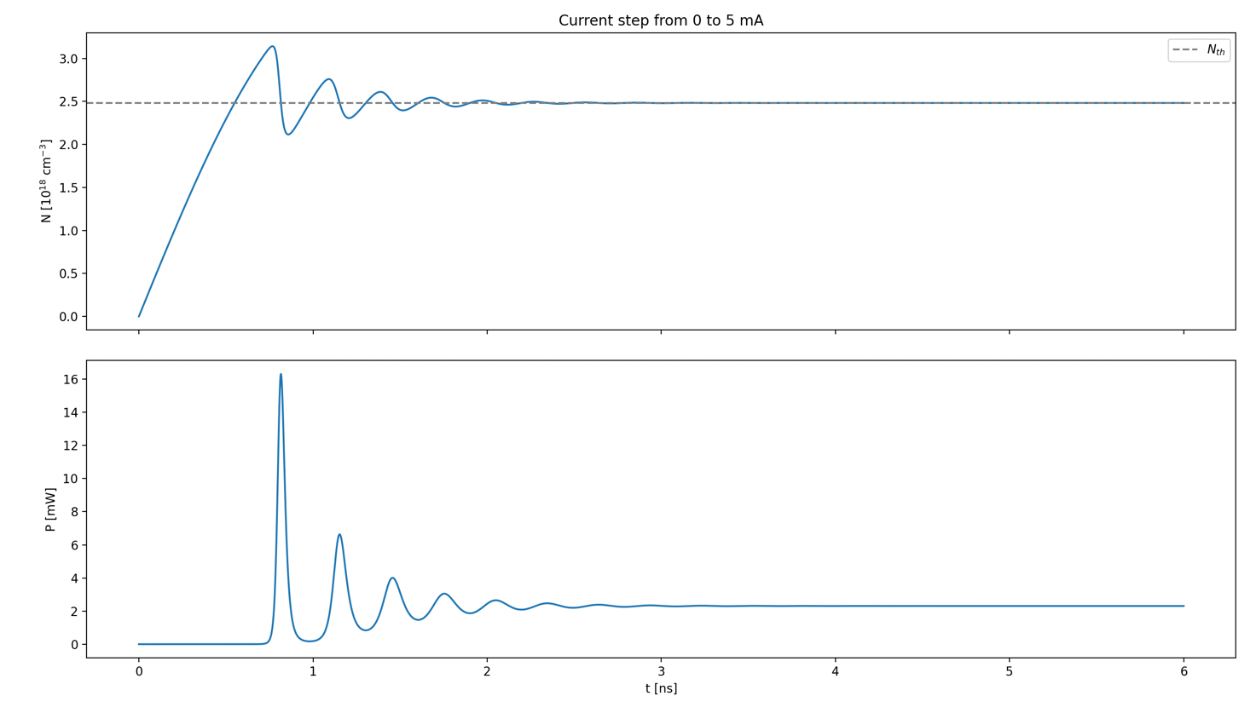

- The second plot shows the output power and N in steady state against the current.
  - Where is the threshold? Below threshold, where do the injected carriers go?
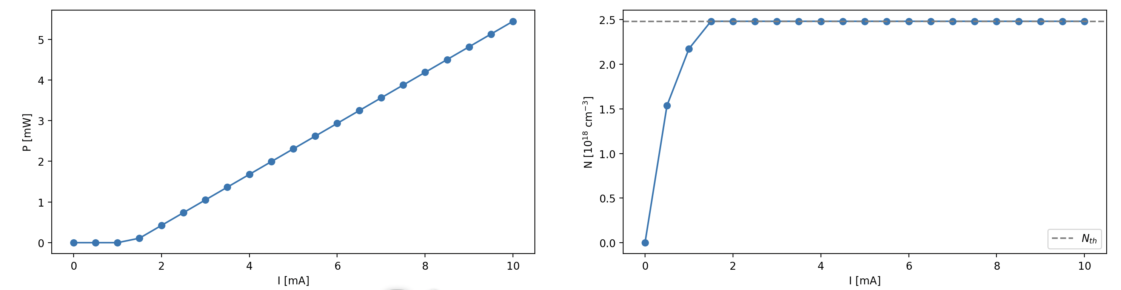
  - Estimate the threshold current from the carrier equation (at threshold, S ≈ 0 and N = Nth), and compare it with the value from the script.

$\dot{N}≈\frac{\left(2,5-0\right)}{1,5}·\frac{{10}^{18}}{{\left(cm\right)}^{3}·mA}=\frac{2,5}{1,5}·\frac{{10}^{18}}{{\left(cm\right)}^{3}·mA} SEQ WMeq2 \backslash r0 \backslash h$ $SEQ WMeq1 1$
$N_{th}≔2,5·\frac{{10}^{18}}{{\left({10}^{-2}·m\right)}^{3}}$
$\dot{N}{\left.​\right|}_{S≈0, N_{th}} =\frac{η_{i}I}{qV_{\text{act}}}-\frac{N_{th}}{τ_{\text{sp}}}$
Thresholden ser kun i forhold til threshold strømmen. Det er ikke tiden vi ønsker at have af betydning. For mine ligninger så gælder der:
$\dot{S}=\dot{N}=0$

$\dot{N}{\left.​\right|}_{S≈0, N_{th}} =\frac{η_{i}I}{qV_{\text{act}}}-\frac{N_{th}}{τ_{\text{sp}}}$
$I=q·\frac{V_{act}}{η_{i}}·\frac{N_{th}}{τ_{\text{sp}}}$
$I=q·\frac{V_{act}}{η_{i}}·\left(A·N_{th}+B·N_{th}^{2}+C_{constant}·N_{th}^{3}\right)=\frac{0,0013455779090039064·C}{s}$
=========
$I≈1,3mA$
=========

  - What happens to N above threshold? Use the photon equation in steady state to explain why, and where the extra injected carriers go.
Above the threshold the density of N exponentially settles towards the carrier density threshold.

- Look again at the current step from 0 to 5 mA.
  - The turn-on delay $t_{d}$ is the time until N reaches Nth, and the build-up time $t_{b}$ is the additional time the light needs to build up. Mark both on the plot. Why are there two separate delays? Why does the light then overshoot and oscillate before settling?
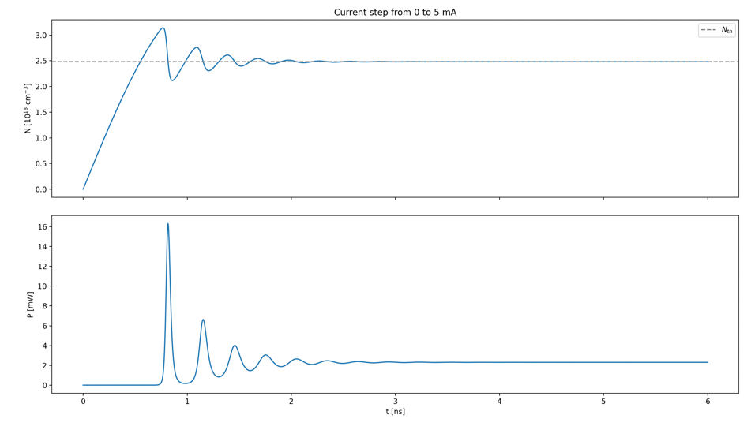

$t_{d}<t_{b}$ as the density settles and then the light have to propagate towards the receiver.

  - In a transmitter, the laser is switched between a low and a high current rather than from zero. The third plot shows steps to 5 mA from bias currents of 0, 0.9 Ith and 1.1 Ith. How do the delay and the overshoot change, and why? Which bias would you choose for a data transmitter, and what does it cost?

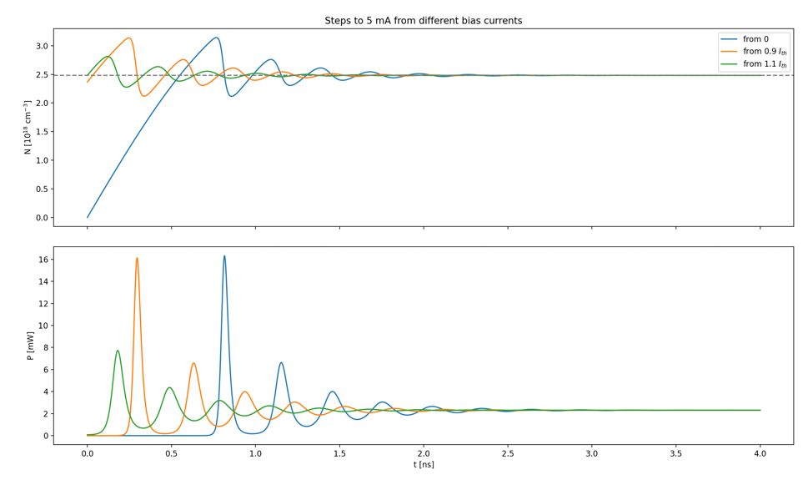
It seems that $∆t=∆t=∆t$, so that isn’t what to design for. The time between the time delay and the time building is relative. It seems as before meeting the threshold current, biasing means the settling times becomes quicker. After meeting the threshold current, stability then becomes increasingly better, as the overshoot percentage decreases.

9.2. Small signal modulation ( % )
To send data, the current through a laser is varied around a fixed bias above threshold. How fast the output power can follow these variations sets the maximum data rate. This exercise finds the modulation response of the laser by linearizing the rate equations.
- The current is modulated as $I\left(t\right)=I_{0}+δI·\cos\left(Ωt\right)$, with $I_{0}$ above threshold.
  - What must be assumed about δI, and about the response of N and S, for the rate equations to be linearized?
$$N_{0}>N_{0p} \& N_{0}^{2}≫N_{0p}^{2} \& N_{0}^{2}≫N_{0p}S_{0p}$$
Hvilket gør udtryk med den anden harmoni af grundtonen negligerbare.

  - Writing $N=N_{0}+δN·e^{jΩt}$ and $S=S_{0}+δS·e^{jΩt}$, with steady-state values N0, S0 and small complex amplitudes δN, δS, and keeping only terms of first order in the small quantities, the rate equations become
$iΩ·\left(\frac{δ N}{δ S}\right)=J·\left(\frac{δ N}{δ S}\right)+\left(\begin{aligned}\frac{η_{i}δI}{q·V_{act}} \\ 0\end{aligned}\right),$
with
$J=\left(\begin{matrix}-\left(A+2·BN_{0}+3CN_{0}^{2}\right)-v_{g}·a·S_{0} & -v_{g}g\left(N_{0}\right) \\ Γ·v_{g}·a·S_{0}+2·Γ·β·B·N_{0} & Γ·v_{g}·g\left(N_{0}\right)-\frac{1}{τ_{ph}}\end{matrix}\right)$

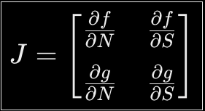
J contains the partial derivatives of the right-hand sides of the rate equations with respect to N and S, at the steady state. What does each of the four entries mean physically? Which entries couple the carriers and the photons, and how does this coupling make the laser oscillate?

$$J∈\left[\begin{matrix}\frac{∂f}{∂N} & \frac{∂f}{∂S} \\ \frac{∂g}{∂N} & \frac{∂g}{∂S}\end{matrix}\right]$$
$J\left[0, :\right]$ Carrier densiteten i forhold til ændring i carrier og photon densitet, henholdsvis.
$J\left[1, :\right]$ Photon densiteten i forhold til ændring i carrier og photon densitet, henholdsvis.
$J\left[:, 0\right]$ ændring I carrier densiteten skaber baggrund for forskellige dynamikker.
$J\left[:, 1\right]$ ændring I photon densiteten skaber baggrund for forskellige dynamikker.

  - The script solves this equation for each modulation frequency and plots the modulation response |δS(Ω)/δS(0)| for bias currents of 2, 5 and 10 mA. Where is the peak, and how do its position and height change with the bias current? Compare the peak frequency with the relaxation $f_{R}=\frac{1}{2π}·\sqrt{v_{g}·a·\frac{S_{0}}{τ_{ph}}}$ and with the oscillations after the current step. What is the 3-dB bandwidth? Which common electrical circuit has a response of this shape?

- In a data link, the bits are encoded in the output power of the laser.
  - What are NRZ-OOK and PAM-4? Sketch the output power against time for the bit sequence 10110001 in each format. How many symbol periods does each format need for these eight bits?
  - Sketch the eye diagram of an NRZ-OOK signal and explain what it shows. Where should the receiver sample the signal?

